**OSINT exercise #004 (Gralhix)**

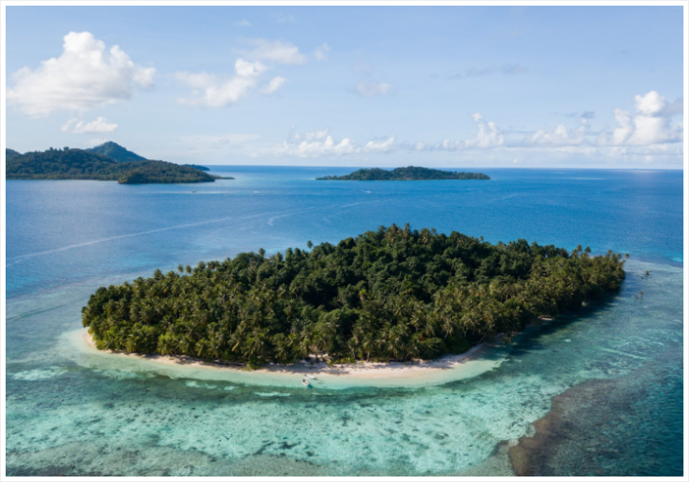

I start by Google reverse image searching the image, and I see a result from Wix.com that shows the exact same image. Going to this website shows the title Oan Resort, which answers the first question of this exercise. The second question is what are the coordinates of this island. So I want to search the website to find out the name of this island. When I go to the about page, there is actually a movie clip showing the location on Google Earth. It mentions that the resort is located on the island of Oan, which makes sense. The movie also shows some coordinates, but I want to look these up myself in Google maps. In Google maps I find the following coordinates for the Oan Resort specifically: 7.36264487133748, 151.7562622801101. To see which cardinal direction this photo was taken from, I look up the location in Google Earth Pro, so I can adjust the perspective. I managed to capture the same perspective in Google Earth Pro, by lining up the islands seen in the background of the photo. So this photo was taken in the North-West direction.